## *MP*Merchant Name *(AE to fill)* Paiv AI - https://www.paiv.ai/ Implementation POC: Jeff Jean *(IM to fill)* CX POC: *[IMP to Add]*

### 

### 

| Notes Sections   *(AE to fill if they have, Implementation to be completion DRI on handoff)*   * Info on how merchant bills   + They bill for a platform with different modules. Their clients pay per user, upfront at contract execution. They use a CPQ connected to HS to generate quotes   + Seat-based usage model - This is not supported well in the platform.   1) What is the merchant temperament?   Jason is great. Young, very intelligent. They are trying to be a profitable business and he cares a ton about cash forecasting.  Disorganized business. Cacheflow deprecating the day of where they are buying Tabs leaving them with no billing software going into next week, requiring us to expedite implementation.  3) What are the Tabs features that the key POC cares about?  Cash Forecasting, Collections, Invoicing, Revenue Reporting, Pushing Stripe Fees onto customers.  Paiv is a bootstrapped business doing ~$1M in ARR. Jason has no visibility into collections, DSO, and cash forecasting today. With their goal to be profitable in 2025, he is intently focused on accurately forecasting cash and using Tabs AI billing manager to streamline collections. He also wants to push stripe fees onto his clients to capture revenue there. Every dollar matters to their business and he was blown away with our collections and cash forecasting features |
| --- |

### Billing model *(Entire Section: Implementation to fill section)*

* Are there unique things about the customer creation process for this merchant?
* Information on how merchant bills
* How contract is broken up
* One off things to know about the merchant

### Contract Processing Steps *(Entire Section: Implementation/Success to fill Post-Go Live)*

1. Steps to process
   1. Service Start Date: Refer to the "Contract effective start date”.
   2. Months of Service: Match the billing period to the months of service
      1. Examples:
         1. 1 every 1 month → RS = 1 month
         2. 1 every 2 months → RS = 2 months
         3. 3 every 3 months → RS = 9 months
   3. Item Name: Look under the "Subscription" table for the itemized services.
   4. Item Description: leave blank
   5. Integration Item: 1:1 match to the item name.
   6. Billing Type: Usually flat pricing.
      1. Check under the General Terms section for any usage pricing.
   7. Total Price: Refer to the Total Price column for each item.
      1. Exception: If the gross amount has a strikethrough, process that along with the discount (the result should be the net amount in bold)
      2. Include net $0 items
      3. **For change orders**, include any BTs despite the amount of change order
      4. **If payment schedule amounts are different from the line item amounts,** follow the payment schedule
   8. Quantity: Refer to the Quantity column. Default to 1 unless otherwise specified.
   9. Start Date: Refer to the “Billing Start Date”.
   10. Periods: Refer to the length column.
   11. Frequency: Refer to the Billing Frequency - whether monthly, yearly, or otherwise.
   12. **Flag to Ashni/Marshal to set up auto-pay once processed and reviewed**
   13. **Exceptions**: If you see a contract with quantity increases over time, **please flag to Ashni/Marshall** and process as follows:
       1. Example: d5de5964-b00e-4e18-a9fd-9c2b8af98c54
          1. BT#: Item Name; Period every Frequency; Total Price; Start Date
          2. BT1: Implementation; 1 every 1 month; $199 x 1 = $199; 3/13
          3. BT2: Field; 1 every 2 months; $59 x 25 x 2 = $2,950; 3/13
          4. BT3: Field; 1 every 1 month; $59 x 45 = $2,655; 5/13
          5. BT4: Field; 3 every 3 months; $59 x 45 x 9 = $23,895; 6/13
          6. BT5: AI Voice; 1 every 2 months; $0; 3/13
       2. Break out the additional month as a separate BT if quarterly frequency (refer to above example)
       3. Dates for both billing and revenue to match the contract
          1. For the broken out BT, US team to change the date to match it to the first invoice in the front end
          2. In the above example, Intl team would process BT3 with a start date of 5/13 and then the US team would change it to 3/13
       4. Discounts would be in-line instead of being a separate billing term

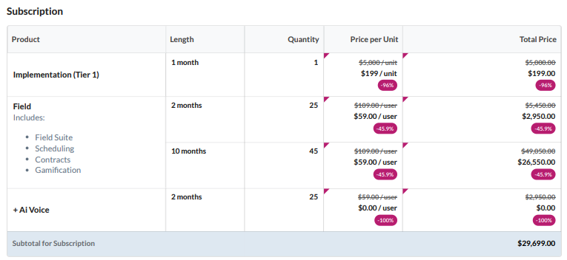

1. **US TEAM Ask**:
   1. Ops team to go into the merchant app to set up “Auto-Pay” for the merchant
2. Anything to ignore in contracts?
   1. No
3. Specifics processing things the merchant has requested that may differ by contract (e.g. always back-date invoice date to final day of the month)
   1. No
4. Default Service Term
   1. If None Listed, Ops Default is 1 Year
5. Default Net Payment Terms
   1. If None, Ops Default is 0
6. Default Billing Frequency
   1. If None Listed, Ops Default is Monthly
7. How do we handle taxes as a line item?
   1. If None Listed, Ops Default is every tax line item becomes a BT

### Events Processing (if necessary) *(Entire Section: Implementation/Success to fill Post-Go Live)*

* Match or create events as listed in the contract.

Integration Items Processing (if necessary)  
*(Entire Section: Implementation/Success to fill Post-Go Live)*

* 1:1 match with the item name

Post Processing Communications (if necessary)  
*(Entire Section: Implementation/Success to fill Post-Go Live)*

* Does the Ops Team need to notify anyone on the team re: completion of processing batches in Implementation or Active phase?
* Who needs to be notified and when?
  + Example:
    - Who: Customer Success [Azmat Aziz] needs to be notified
    - Where: Messari internal merchant channel
    - When: contracts are processed [Merchant Phase: Active]

### Customer Information *(Entire Section: Implementation/Success to fill Post-Go Live)*

* All customers on auto-pay

### Feature Requests *(AE to fill for all requests prior to Imp handoff, Imp to fill prior to go-live/Success to fill to fill Post-Go Live)*

* None

### Merchant Calls *(AE to fill for all videos prior to Imp involvement, Imp to fill prior to go-live/Success to fill to fill Post-Go Live)*

* Disco 2/21
  + https://us-56595.app.gong.io/call?id=1533614975165014373
* Demo 2/25
  + https://us-56595.app.gong.io/call?id=7896536761369543914